Pregunta 6.39

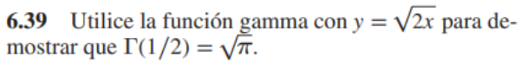



RESPUESTA

Pregunta 6.40

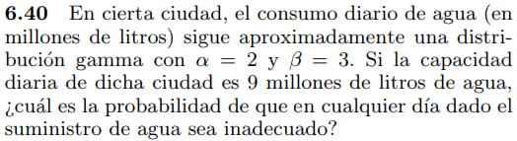

RESPUESTA



Pregunta 6.41

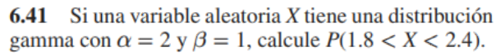

RESPUESTA



Pregunta 6.42

RESPUESTA



Pregunta 6.43

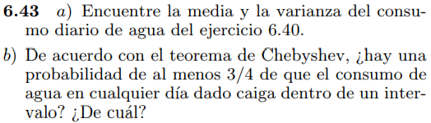

RESPUESTA

Pregunta 6.44

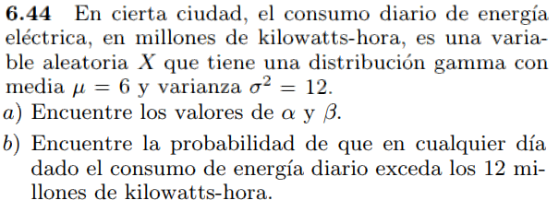

RESPUESTA

Pregunta 6.45

RESPUESTA

Pregunta 6.46

RESPUESTA

Pregunta 6.47

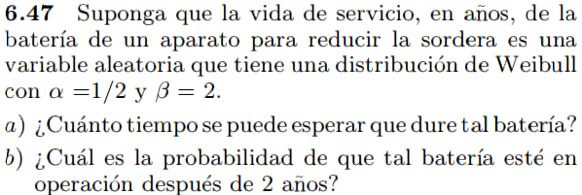

RESPUESTA

Pregunta 6.49

RESPUESTA

Pregunta 6.50

RESPUESTA

Pregunta 8.44

RESPUESTA

Pregunta 8.45

RESPUESTA

Pregunta 8.46

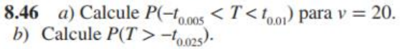



RESPUESTA

Pregunta 8.47

RESPUESTA

Pregunta 8.48

RESPUESTA

Pregunta 8.49

RESPUESTA



Pregunta 8.50

